3HO ASIA Kundalini Yoga Festival

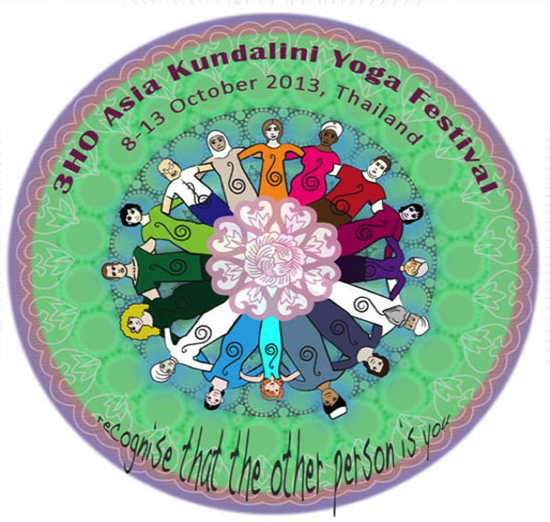

October 10, 2015
(arrival either 4am for Sadhana or by 7:30am check in)
White Tantric Yoga Registration
Thai Residents and Thai Nationals

First name: | Last name:
Spiritual name:
Country of residence: | Nationality:
Mailing Address:
Phone(s): | Email:

__ One Day White Tantric Fee 5,000 Baht (includes Lunch)
arrival time 7:30am on Oct 10 , if you attend Sadhana at 4am on Oct 10 with breakfast add $10 USD

__ extra night add this amount, please indicate date/time arrival – shared room 1,000 Baht includes dinner & breakfast - Arrival date: time: departure date:

INDIVIDUAL PAYMENT
To register as an INDIVIDUAL
Advance payment by bank transfer or deposit to the following:
Account: Susan Adler-Shaw
Bank Name: Siam Commercial Bank
Bank Address: Siam Paragon Branch
Account no. : 218 204340 5
Note: Please add to your payment Bank transfer charges.

_____Mark here if you want to pay at registration check in – payment in cash only as credit card usage is not open at that time. (payment Thai Baht) – (payment in cash Thai Baht will be based on currect exchange rate on Oct 10)

Please fill in registration and notice of payment to Satya Kaur via email to:
event-info@3hoasia.org

NOTE: All registrations and advance payments shall be confirmed by email. THANK YOU!

