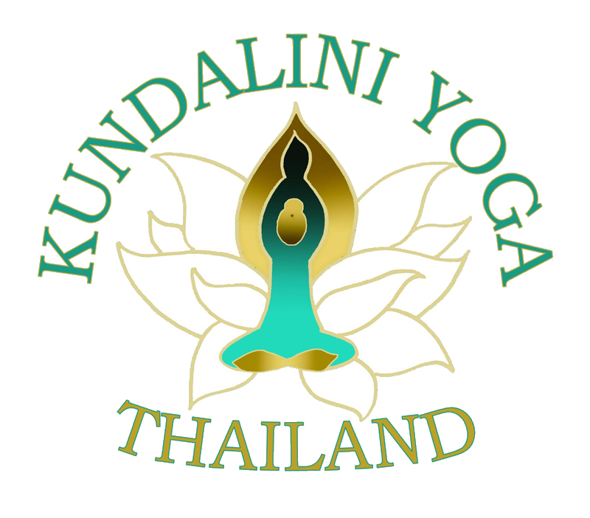

Kundalini Yoga Thailand Retreat
20-24 October 2016 - Suan Bua Resort
Registration Form – Health Questionnaire - Disclaimer

First Name: |  | Last Name: | Spiritual Name:
Home Address:
Email:
Phone No.:
Check below for shared room or single room
Shared room: | Single room:
Date of Birth: | Male: |  |  | Female:

Package Rates
Early Bird price received by August 31 shared room 12,500 per person Baht / single room 15,100 Baht
After August 31 room 13,300 Baht shared room per person/single room 15,900 Baht
Children’s Rates: children not over 2 years old no charge – children 3-10 years old 2,800 Baht per child without extra bed; with extra bed 4,800; with extra twin bed 5,400
Children 11 and older same rates as adult

inclusive of the following:
- arrival 20 October late afternoon with dinner – depart 24 October after early morning Sadhana and breakfast
- Sadhana 4am-6:30am 21,22,23,24 October
- workshops several choices per day
- 4 breakfasts, 3 lunches, 4 dinners (all vegetarian meals), 2 snacks per day
- airport pickup and return*

*please arrange your air travel with others as to facilitate airport pickup and return, select a group leader to
arrange time of group pick up and time of departure– group leader reports how many people in your group, names of people in your group, and flight details - email information to event-info@kundaliniyogathailand.org
*For one person pickup there may be an extra charge

Teach a Workshop – If you would like to teach a workshop check here ______.
The workshop form will be sent to you with retreat rate for teachers teaching a workshop.

Payment made to the following account:
Account Name: Akarat Sivaphongthongchai
Bank Name: Siam Commercial Bank (SCB)
Account number: 218-2-28318-6
Branch: Siam Paragon
Type of account: Savings Account
Swift code: SICOTHBKXXX
Note: after making payment send copy of bank receipt to event-info@kundaliniyogathailand.org
Will send confirmation of payment only after receiving copy of bank deposit or bank transfer receipt.

**If you would like to contribute to Kundalini Yoga Thailand scholarship fund (any amount) to help people attend this retreat and future events who have limited funds, please note here: amount _________ and add on to your
payment. This fund will be used for Thailand events to assist those in need. Thank you for your contribution!

Kundalini Yoga Thailand - HEALTH QUESTIONNAIRE
Please fill in as appropriate
Note: all information shared will be considered confidential and private

Please check if you have a history or recent occurrence of:
-Allergies |  | -High blood pressure
-Arthritis |  | -Hypoglycemia
-Asthma |  | -Low blood pressure
-Back pain |  | -Infectious diseases
-Breathing difficulties |  | -Major injuries
-Broken bones |  | -Neck pain
-Cancer |  | -Other pain in the body
-Diabetes |  | -Regular headaches
-Heart diseases |  | -Ulcers
-Any hospitalization / Operations? (please specify)
-Are you pregnant? How many months?
-Do you smoke?
-Are you taking any medication (please specify)?
Rate the level of stress in your life - High/Medium/Low :
Please describe any other condition we should be aware of:

1. What do you hope to gain from this yoga training?
2. How did you hear about this Kundalini Yoga Event:
3. Would you like to be on the Kundalini Yoga Thailand emailing list?
4. List other forms of exercise of sports you participate in:

Kundalini Yoga Thailand Retreat 2016
DISCLAIMER
PLEASE READ CAREFULLY BEFORE SIGNING BELOW

I, _______________________________ hereby agree to the following:
First and Last Name

I am aware that participation in yoga may result in accident or injury, and I assume the risk connected with the participation in yoga and attest that I am in good health and suffer from no physical impairment that would limit my ability to participate in this Kundalini Yoga Thailand event. I personally acknowledge that teachers of this Kundalini Yoga Thailand event have not and will not render any medical services including medical diagnosis of participants’ physical condition.

I specifically agree that the organizers and teachers of this Kundalini Yoga Thailand event shall not be liable for any claim, demand, cause of action of any kind whatsoever for, or on account of death, personal injury, property damage, or loss of any kind resulting from or related to my use of the course facilities within or without the course premises.
I have read the above release and waiver of liability and fully understand its contents. I voluntarily agree to the terms and conditions stated above.

Signature of participant:
Date:

For participant under 18:
AS LEGAL GUARDIAN OF __________________ I GIVE PERMISSION TO HIM/HER TO PARTICIPATE IN THE AFOREMENTIONED TRAINING AND CONSENT TO THE ABOVE TERMS AND CONDITIONS.
Date: ___________________
Name & signature of parent / legal guardian: _________________________________

