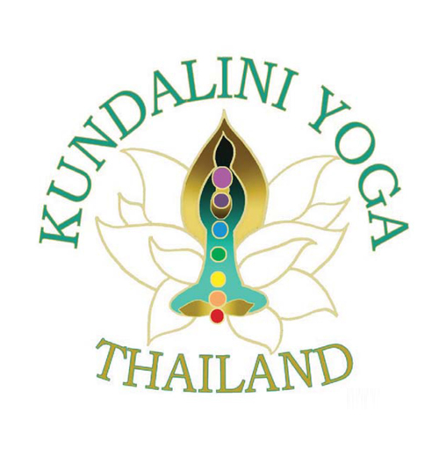
Three Workshops at Baan Phu Waan

REGISTRATION FORM –
TO RESERVE YOUR SPACE, COMPLETE THE FORM AND EMAIL IT TO
event-info@kundaliniyogathailand.org by February 10, 2020.

NAME:
EMAIL:
PHONE:

Do you live in Thailand?
Are you visiting Thailand?
note: options 5 & 6 for visitors have a supplemental fee see below

SELECT THE OPTION YOU WOULD LIKE TO JOIN BY HIGHLIGHTING IT IN YELLOW.
- 1 half-day workshop
Saturday Feb 15 ‘Divine Alignment’ - 9:15-12:15 includes inclusive
of Sadhana at 4:30am with breakfast and lunch – 1,600 Baht

2) 1 half-day workshop
Saturday Feb 15 afternoon ‘Sacred Circle – Being the Witness’
2:15- 5:15 includes lunch at 12:30 – 1,600 Baht

3) Special Package with 2 workshops
Saturday morning & Afternoon workshops includes Sadhana at 4:30 breakfast and lunch 2,600 Baht (dinner is extra 600 Baht – 3,200 Baht)

4) 1 all day workshop –
Sunday Feb 16 ‘Western Anatomy’ 9:15-12:15 and 2:15-5:15 includes Sadhana –
breakfast and lunch 2,600 Baht – dinner option plus 600 Baht 3,200 Baht

5) Special Package 1 night single room 2 workshops
stay over Friday night with dinner with 2 workshops on Saturday 3,400
Baht Sadhana – includes breakfast and lunch (dinner Saturday night extra 600
Baht)
International single room 4,000 Baht
6) Special Package 1 night single room 1 workshop
stay over Saturday night starts with dinner –Saturday Sadhana, Breakfast
lunch inclusive - Sunday workshop 3,000 Baht

7) Special Package 2 nights single room - 3 workshops
Friday & Saturday night
with dinner Saturday and Sunday workshops –
single accommodation 6,100 Baht
single room dinner Sunday night extra 600 Baht workshops 6,600 Baht
(International 7,300 Baht)

Any further inquiries contact Satya at: event-info@kundaliniyogathailand.org
or phone 089 212 1782

http://www.kundaliniyogathailand.org

